**Littlefield Technologies Simulation Report**

**Team Name: SmoothOperators**

**Authors: Naina Grover, Marlis Williamson, Sin To, Rachel Silver**

**Section: 52**

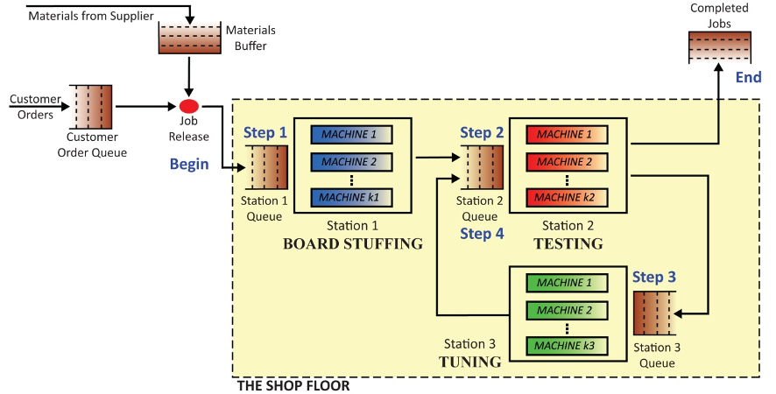

**Problem Statement**

Littlefield Technologies makes money by delivering Digital Satellite System (DSS) receivers to customers quickly after processing and assembling product kits. Completed DSS receivers earn the company greater revenues when finished in a shorter time period depending on the type of implemented contract Littlefield Technology and is penalized for not delivering orders on time to customers. To be successful, Littlefield must mount and solder PC boards, test the components, tune and properly adjust the components, and perform a final test. At the time of control takeover, all stations were at constant maximum capacity and each station had back up of product leading to bottlenecks and longer delivery times to customers. In our initial decision, we looked at the utilization rates and queues at each station to adjust and improve product flow in order to deliver product at an optimal time for customers.

**Capacity Management**

Management's main concern was to manage factory capacity at the three stations- board stuffing, testing and tuning with respect to the complex demand pattern predicted. For the first 50 days, we prioritized understanding the model. From day 70-74, we saw job arrival rate increasing linearly, increasing queues and utilization at station 2. We ran the capacity analysis to find out which station would be a bottleneck and found station 2 to have the highest utilization of 99% (touched 100% later) and least capacity i.e. 9.2605 (Appendix B). In order to level off the capacity, we should purchase machines at that station. Thus, our general approach was to observe utilization patterns and queue size to buy machines when it reaches the highest level. After capacity analysis, we focused on calculating the flow time using throughput and inventories as per Little’s Law i.e I=R*T, to decide the proper contract.

Our approach of eliminating bottlenecks and increasing capacity to meet forecast demand by buying machineries at different stations- 4 at Station 1, 2 at Station 2 and 2 at Station 3 was effective in long term capacity management. Initially, the first two stations had the highest utilizations when we took control. It would have been more effective if we would have realized initially that the huge spike in demand caused a big queue and revenues to drop significantly.

After playing the game, we learned that delays resulting from insufficient capacity would undermine LT's promised lead times and ultimately force LT to turn away orders. The ideal capacity management is to forecast the peak demand and determine the required capacity. Purchasing the capacity before it is necessary is beneficial as the revenues gained by meeting the demand outweigh the opportunity cost of lost interest. Next time we would first calculate the capacity needs and monitor machine performance in demand spike while buying machinery.

**Inventory Management**

Our primary focus for modeling inventory levels was to initially focus on queue sizes in order to see how fast the plant was able to process inventory. As the game progressed, we focused more on ordering an average amount of product based on orders to date. In our initial analysis, we did not focus on the reorder point which would have been more effective for managing inventory going forward. Because we did not properly manage reorder points and calculated it very late, near to 186 days (Appendix D), we frequently ran out of inventory and would see revenue issues and inconsistency in delivery.

If we could run the simulation again, we would calculate the Reorder Point and the Economic Order Quantity at the start (51-70 days), instead of calculating it at a later point. We would have compared the potential increase in revenue against the cost of machines in order to fulfill the demand in the promised delivery time. We also learned that running out of inventory in each order cycle has significant financial implications for the factory and setting too low a reorder quantity can be a costly undertaking.

**Priority Management**

Prioritization at the Testing Station is required throughout the game due to inventory passing through the station twice. From the beginning, the queue at Station 1 self-regulated and was consistently lower than the queue at all other stations (Appendix C part a). However, the queue at Station 2 and 3, first spiked around Day 60 (Appendix C part b&c). Due to this, we changed the priority of Station 2 from FIFO to Priority Step 4. This had a two-fold effect on our factory. First, it allowed more jobs to transition to completion as Step 4 became a priority, which boosted our revenue significantly. The change in priority regulated the factory and reduced queues because inventory wouldn’t reach Station 3 from Station 1 as quickly, since Station 2 was focused on Step 4 instead of Step 2.

With reduced queues and faster system processing, priority was changed back to Step 2. The system now pulled inventory into the factory and started to become a completed job. On day 129, 6 days after priority was set to Step 2, a brief spike in kits queued at Station 2 resulting in reverting priority to FIFO and the queue problems regulated and resolved.

Around day 200, to push more inventory towards completion, we changed priority back to Step 4. However, this was ineffective at this point in the simulation as Station 1 and Station 3 were running at about the same speed. Due to this, a spike in queued kits at Station 1 increased for a brief period before the factory could process inventory in the given lead time. If we ran the simulation again, we would leave our priority at FIFO once the system is regulated, pending other dramatic change.

**Endgame Management**

Before day 214, we had to place the “Big Order” by either making the reorder quality a significant amount more than 1 million, so that our factory will not have that much cash to place the order at the end of 268 days or we could have made the decision to reorder point and reorder quality to equal zero, which would make sure that no other orders would get placed after the “Big Order”. Our team was facing difficulty in calculating the EOQ and planned to do 340 orders and then 627 (averaging 12.55 orders per day x 50 days) orders on day 213 and was supposed to drop to zero (Appendix D). However, due to timing and planning, we did not make the order resulting in huge inventories (37,620) left at the end of the simulation. Improved inventory management could have changed the outcome of our revenue and overall standing.

If we could play this game again, our team would have strategically analyzed our purchases of machines and reorders to see how it affected the revenue, station queues, and our overall standing. Also, we would have made either the “Big Order” or made the reorder point and reorder quality to equal zero based on the professor's feedback.

**Conclusion** (Refer Appendix E)

Through the simulation we learned preparation provides an advantage for strategies and fast paced activities. Delaying calculating the reorder point and economic quantities leads to lost revenue. Running out of inventory in each order cycle has significant financial implications for the factory and setting too low a reorder quantity can be a costly undertaking. Delays resulting from insufficient capacity undermine LT's promised lead times and ultimately force LT to turn away orders. Purchasing capacity before necessary is beneficial and leads to revenues gained by meeting the demand outweighs the opportunity cost of lost interest of capital. Through continuous communication we found and removed bottlenecks. We asked each other about moves, methods, and assumptions to sharpen our thinking which improved our decision-making. We kept an active watch on lead-times and tried to resolve issues through the intense team communication and proactive operations-management. We learned one should go for aggressive contracts, but manage lead times. This game taught us to do proactive capacity management and inventory management. Poor inventory assessment before the simulation end can hurt.

**Supporting Evidence**

**Appendix A: Transaction History**

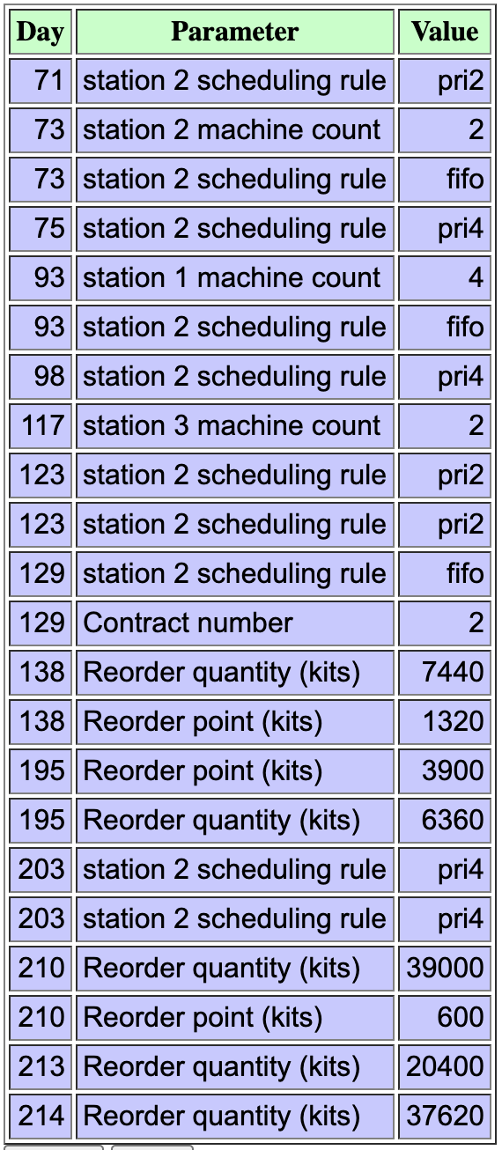

**Appendix B: Capacity Analysis**

|  | | | | **S 1** | **S 2** | **S 3** |
| --- | --- | --- | --- | --- | --- | --- |
| **Days** | **Input** | **Output** | **Inventory** | **Utilization** | **Utilization** | **Utilization** |
| 1-74 |  |  |  |  |  |  |
| Average Data | 11.0676 | 9.1892 | 123.7702 | 0.8734 | 0.9923 | 0.7724 |
| Little's law: I=RT |  | R = Throughput | I | Capacity =  Production / Utilization | Bottleneck at S2 |  |
|  | | | | **Capacity At S1** | **Capacity At S2** | **Capacity At S3** |
|  |  | **Flow time**  **= I/R** | **13.4691** | **10.5214** | **9.2605** | **11.8964** |

**Appendix C: Queue Size Plots**

1. **Daily Average of Kits Queued at S1**

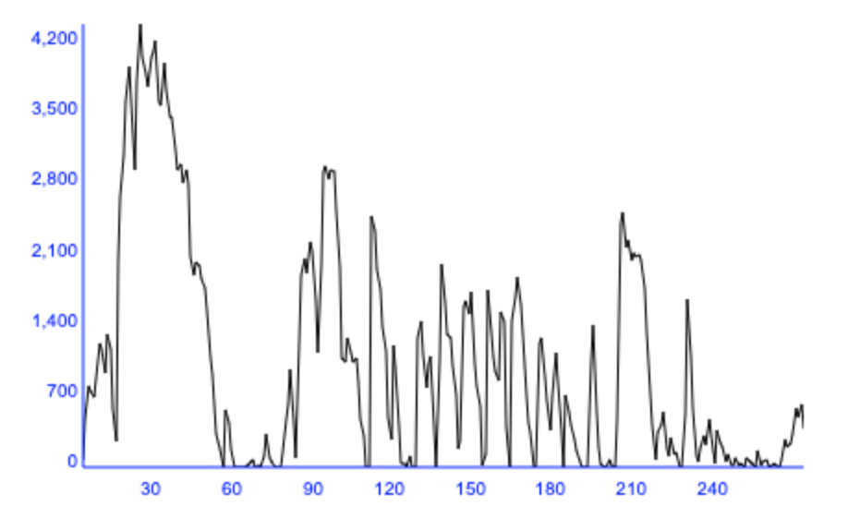

1. **Daily Average of Kits Queued at S2**

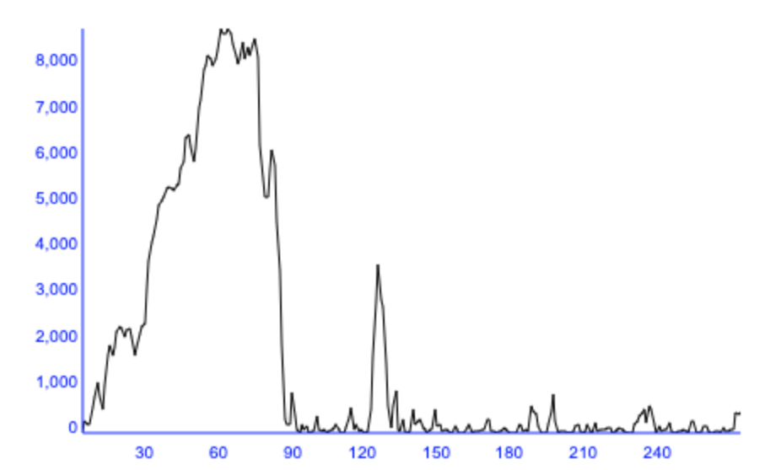

1. **Daily Average of Kits Queued at S3**

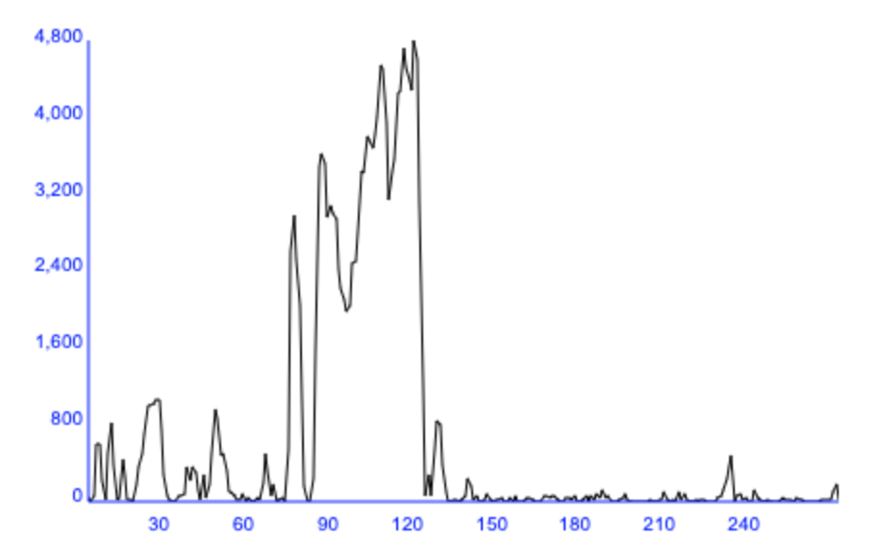

**Appendix D: Stimulation Calculation**

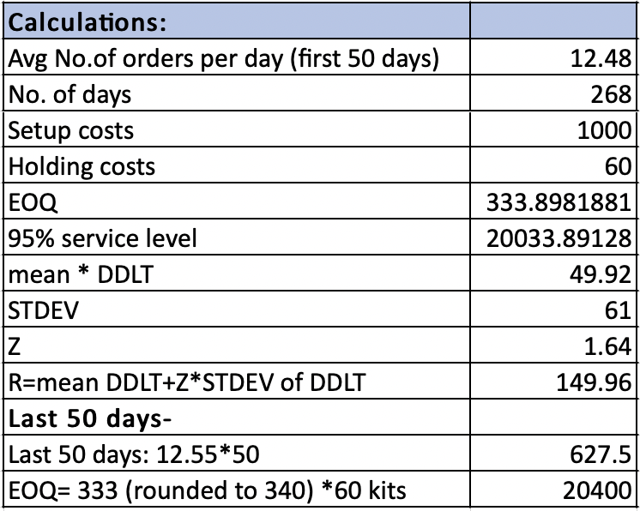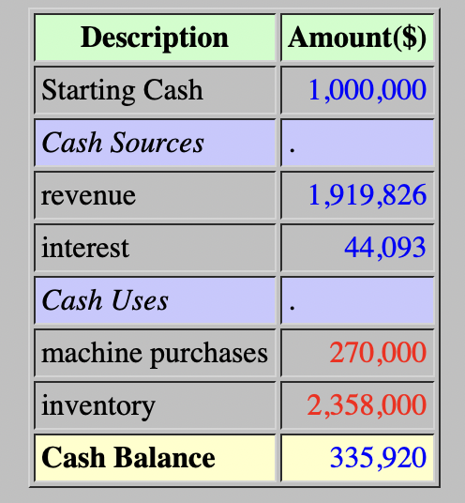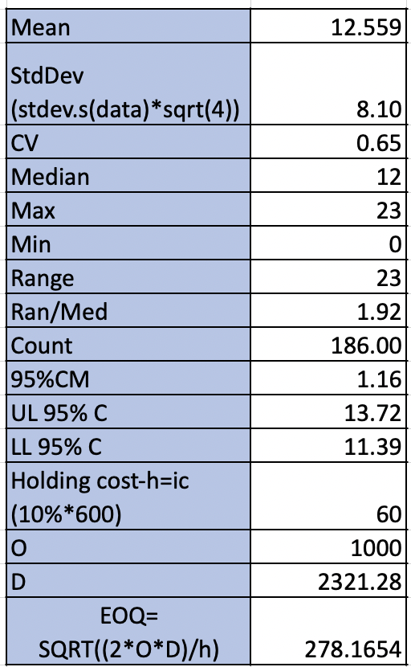

**Appendix E: Operations Prism**

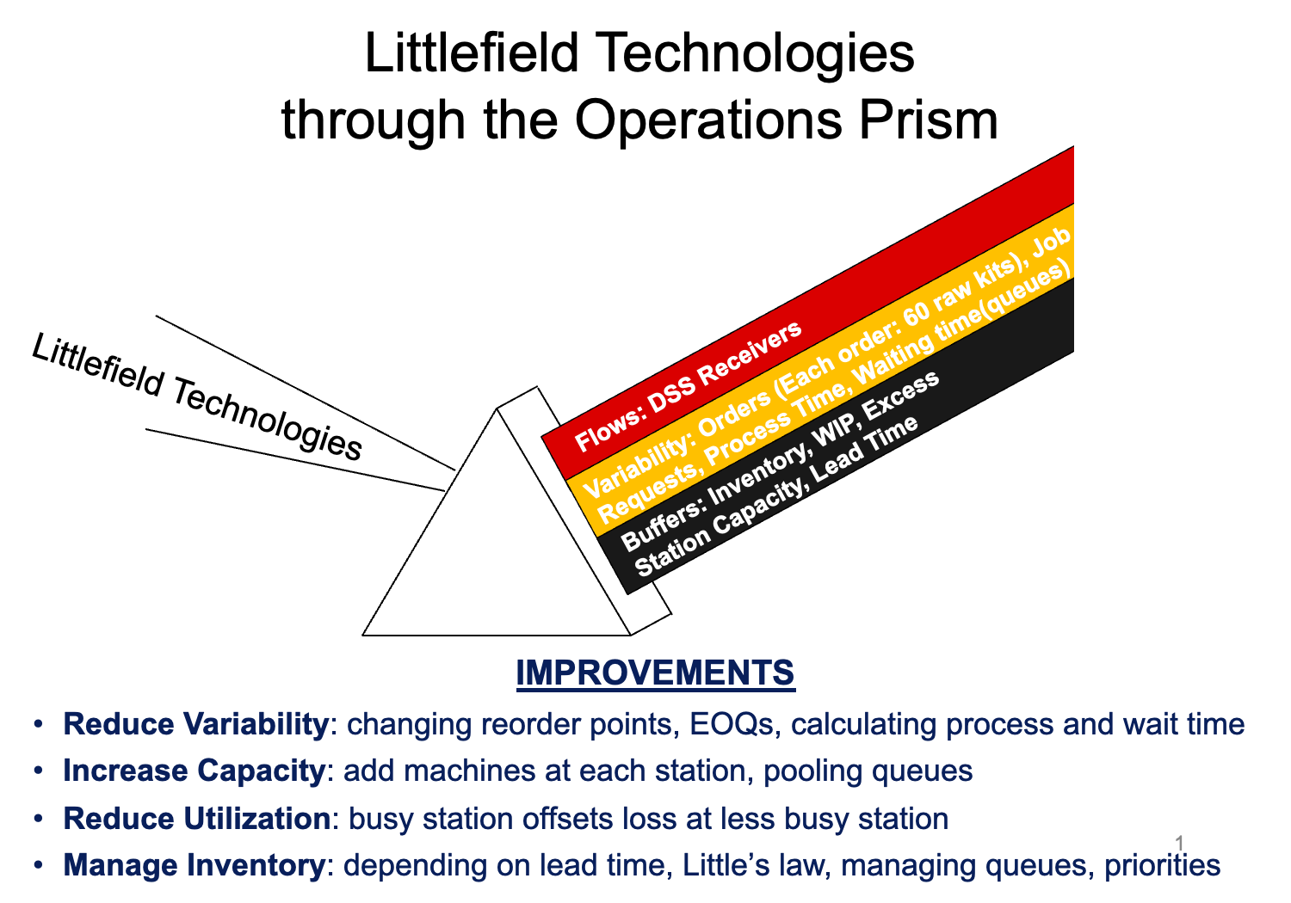

***Grade: 10 points, allocated as follows***

| **Element** | **Points Possible** | **Points Received** | **Comments** |
| --- | --- | --- | --- |
| Problem statement | 2 |  |  |
| Capacity management | 2 |  |  |
| Inventory management | 3 |  |  |
| Priority at tester | 0.5 |  |  |
| Endgame management | 2 |  |  |
| Conclusions | 0.5 |  |  |
| Bonus (for ending cash position) | Up to 1 point |  |  |
| Total | 10 |  |  |